Ruby’s Lockdown Log: April 2021 - Spring out of Lockdown

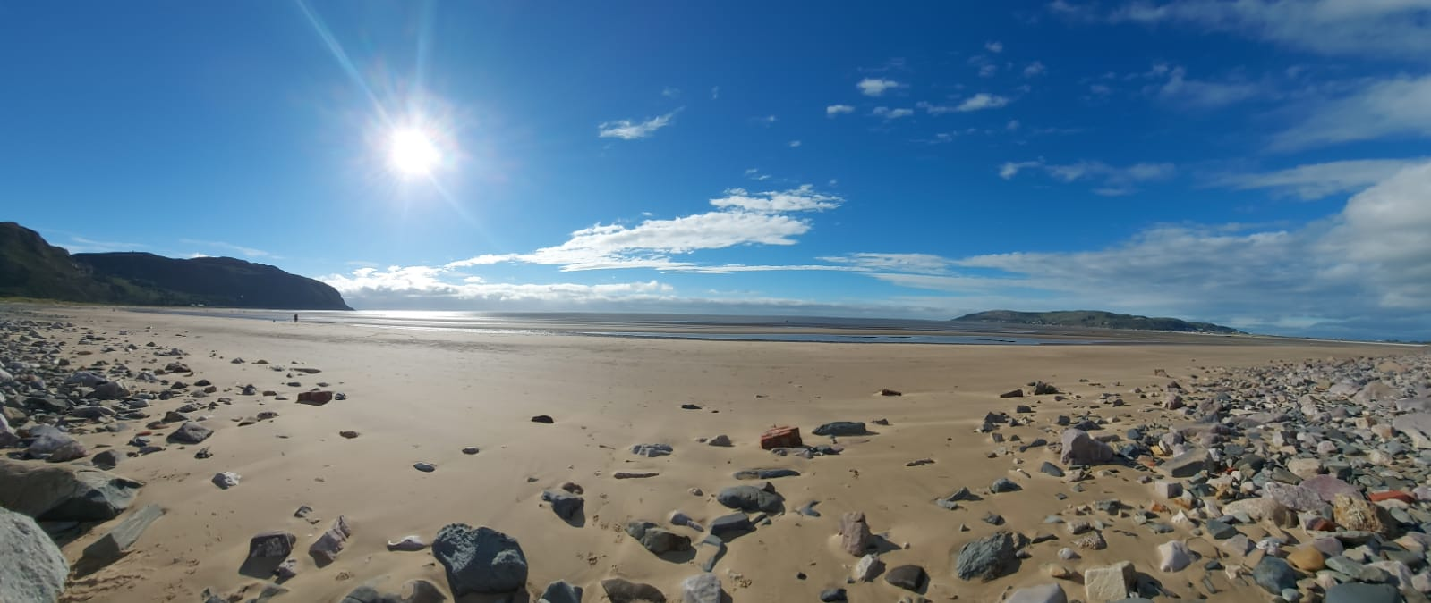
We have enjoyed the freedom of having the Snowdonia National Park to ourselves: the untrodden mountain paths, secret waterfalls, hidden Celtic rainforests, mythical lakes, the isolated beaches. But there’s plenty of room for all of us, and we’ve missed you. It’s been much too long, and we can’t wait for the time when we can welcome you back to this wonderful part of the world.
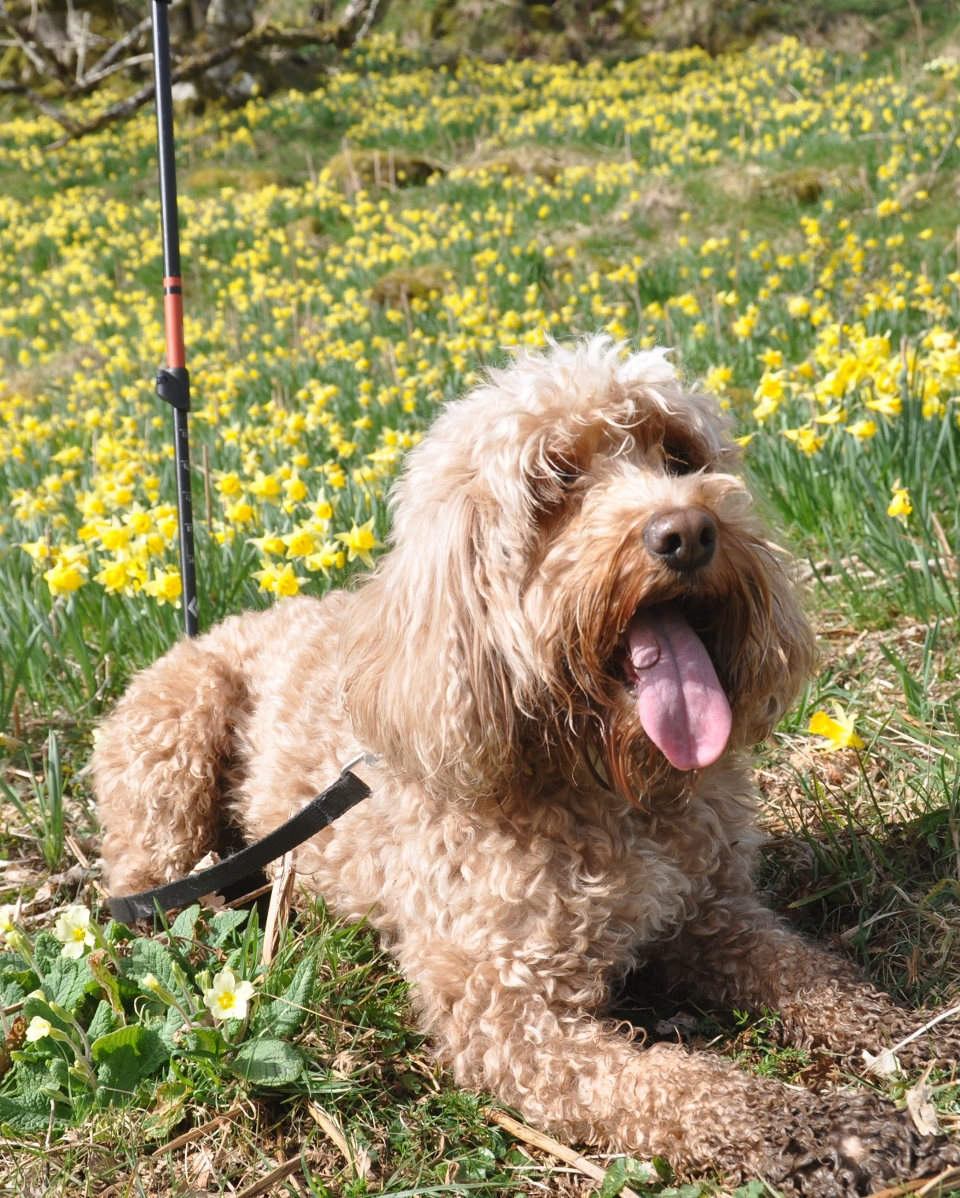
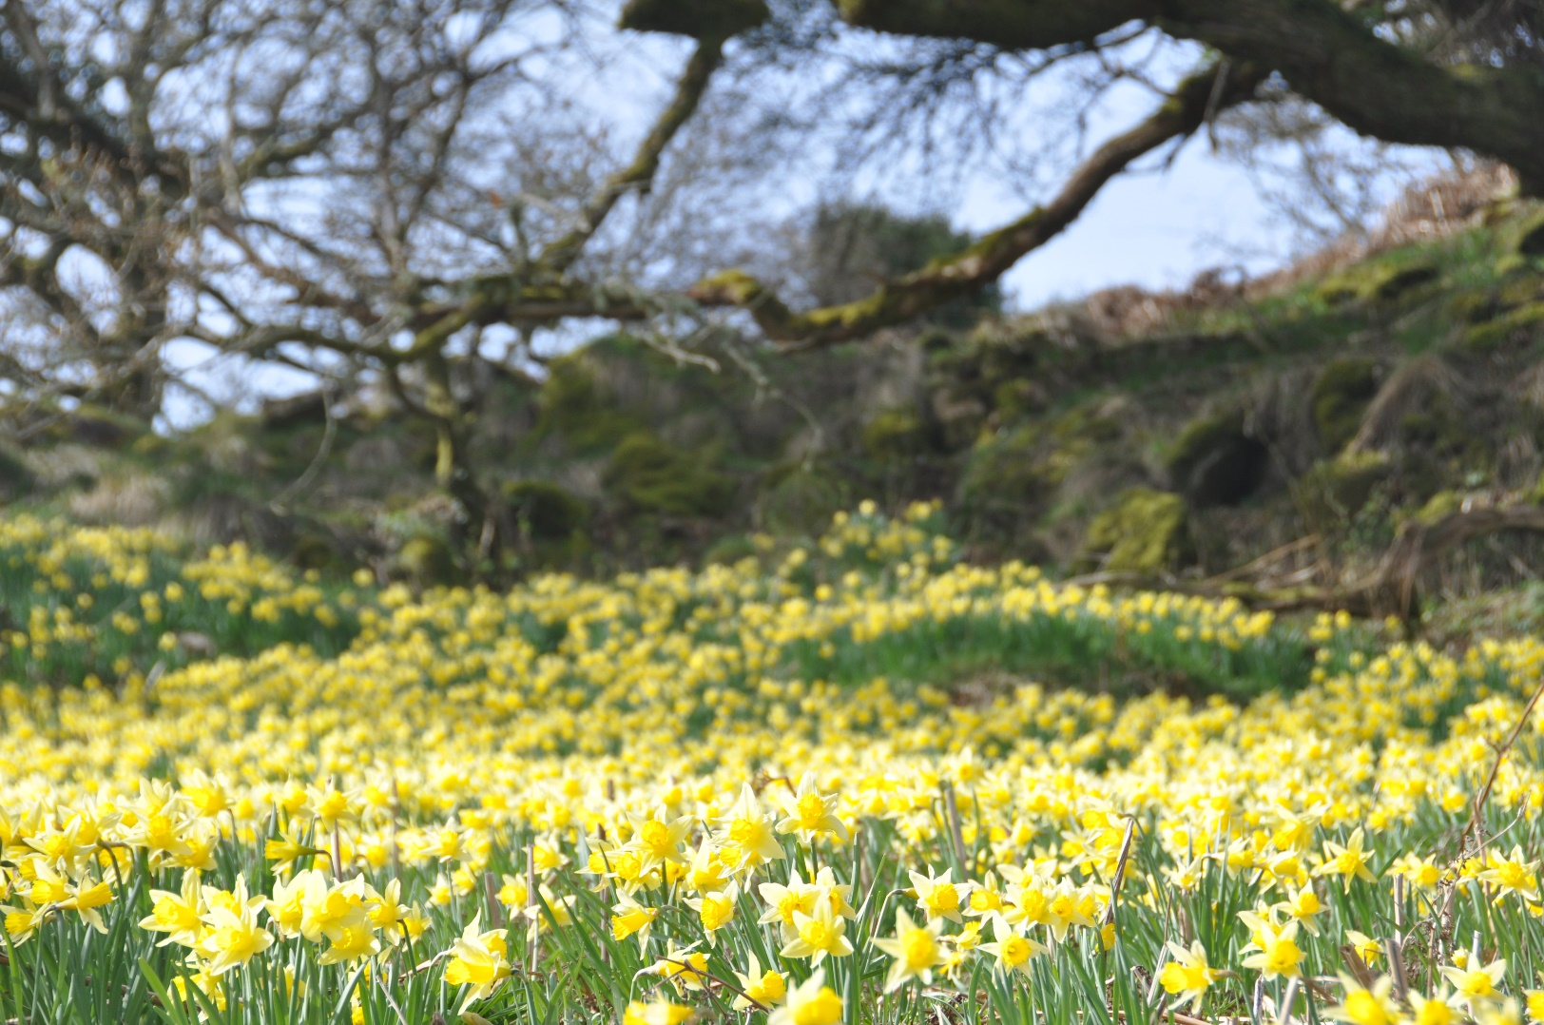

However, you didn’t come here to read anything that we have got to say. This is Ruby’s blog and she is a great explorer in her own right; she is desperate to share with you her adventures since you’ve been gone. Only yesterday she discovered a wild daffodil nature reserve in the Carneddau mountains just near the grade-one listed Llangelynnin church which sits above our village on the Pilgrims Way.
Over to Ruby ……….
Thank you, about time! Welcome to my latest lockdown log, which is the first and hopefully last one in 2021, as I think we’re all getting a little bored of Government announcements and guidance now and just want to get on with our lives.
I imagine you’re thinking that this log is well overdue, as the last one was posted in July last year and you’re right of course. My excuse is that my staff (they like to be called Chris and Sandra) and I were really busy after recovering from the shock of actually having to do some work in August and September, when the Welsh Government took us all by surprise by allowing us to open before changing their minds and shutting everything down again in October. Since then, we’ve been occupying our time with garden projects and making changes to the house so that we can operate in these strange times where everyone seems to be wearing muzzles and talking about someone called Maxine, who I imagine has moved into the village. I haven’t seen Maxine yet, but she does seem to be quite important and apparently employing people, as they keep talking about getting a Maxine job. At least I think that’s what’s happening; it’s quite hard to understand what people are saying when they have muzzles on.
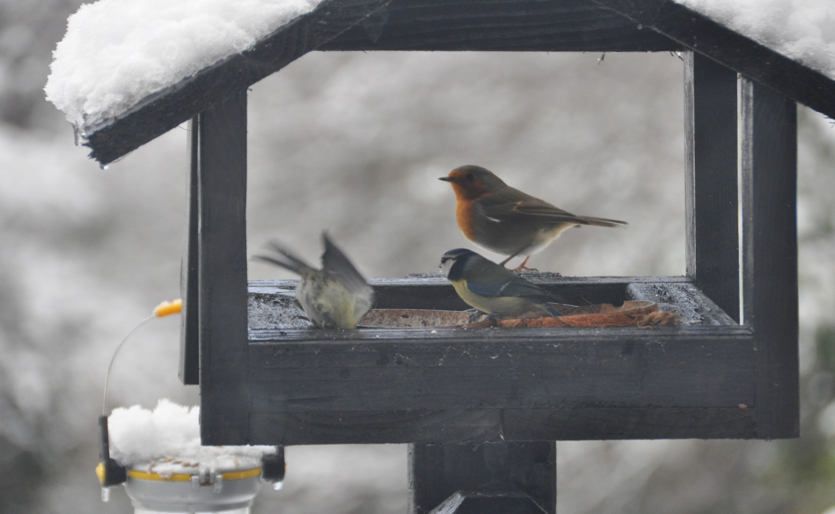
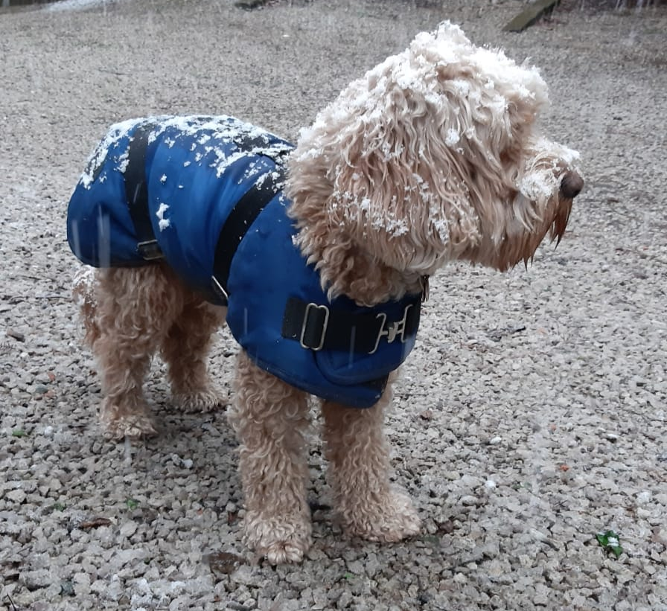
In my last log I mentioned that I was sent a recipe for dog biscuits and I can report that they were absolutely delicious. I definitely didn’t share them with those pesky birds as they eat us out of house and home as it is. I am hoping that someone will soon make some more but it’s difficult to get Sandra away from the kitchen garden. Hopefully, this year she will have learnt from her many mistakes; there have been far too many over-sized, under-sized and off-colour produce. I have suggested she ought to forget everything horticultural and stick to growing pork sausages and smoky bacon.
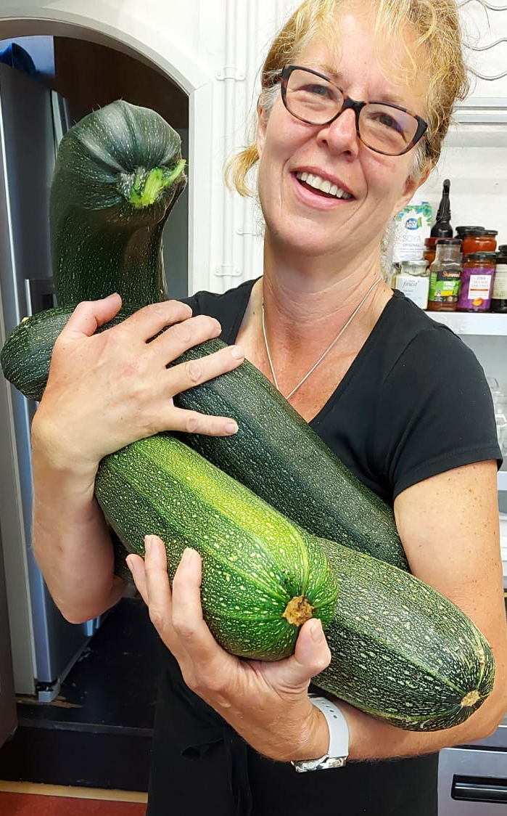
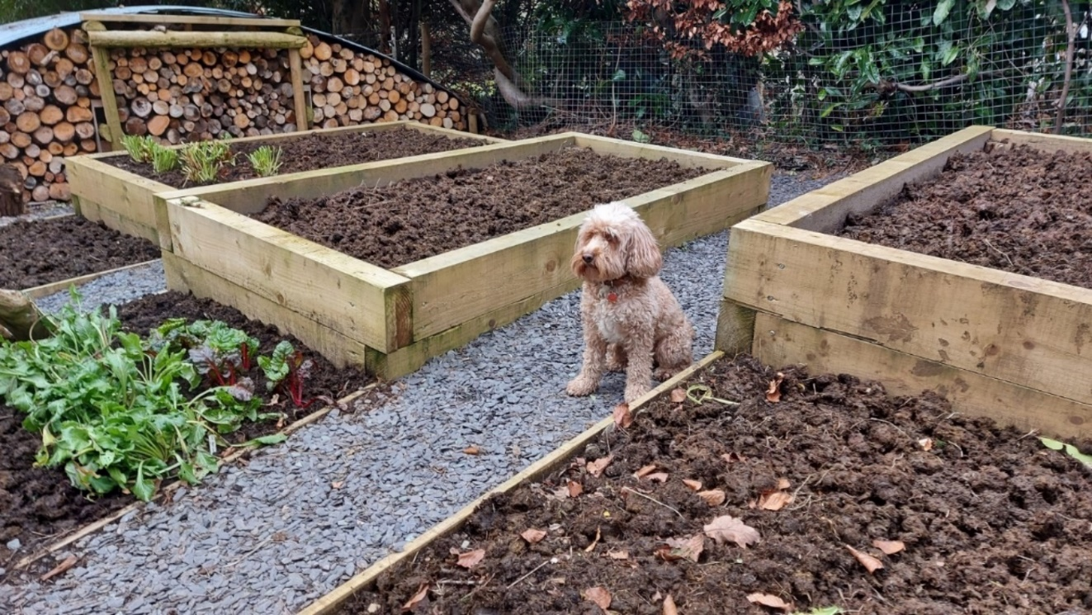
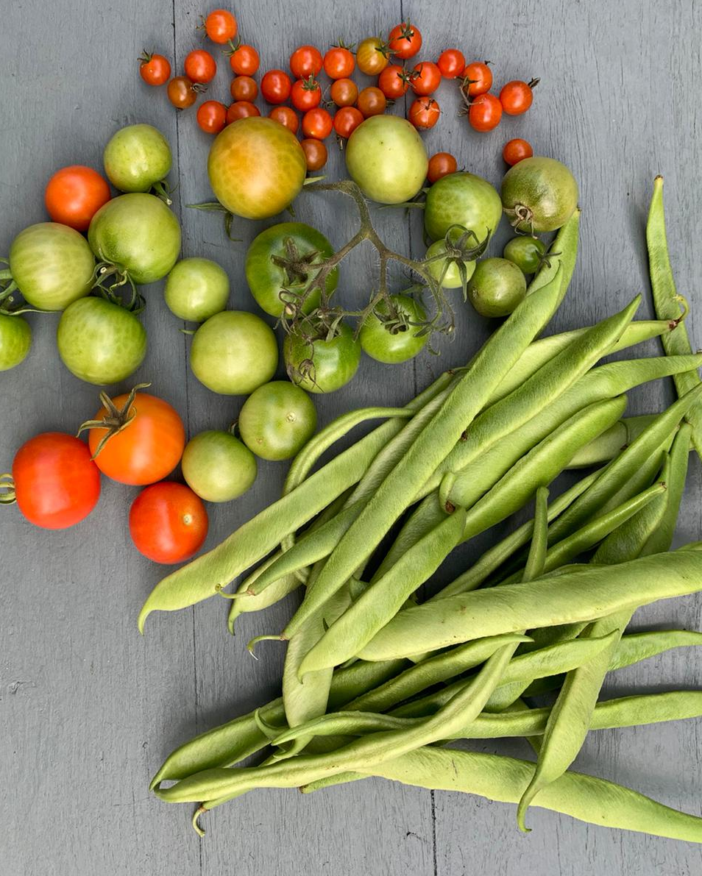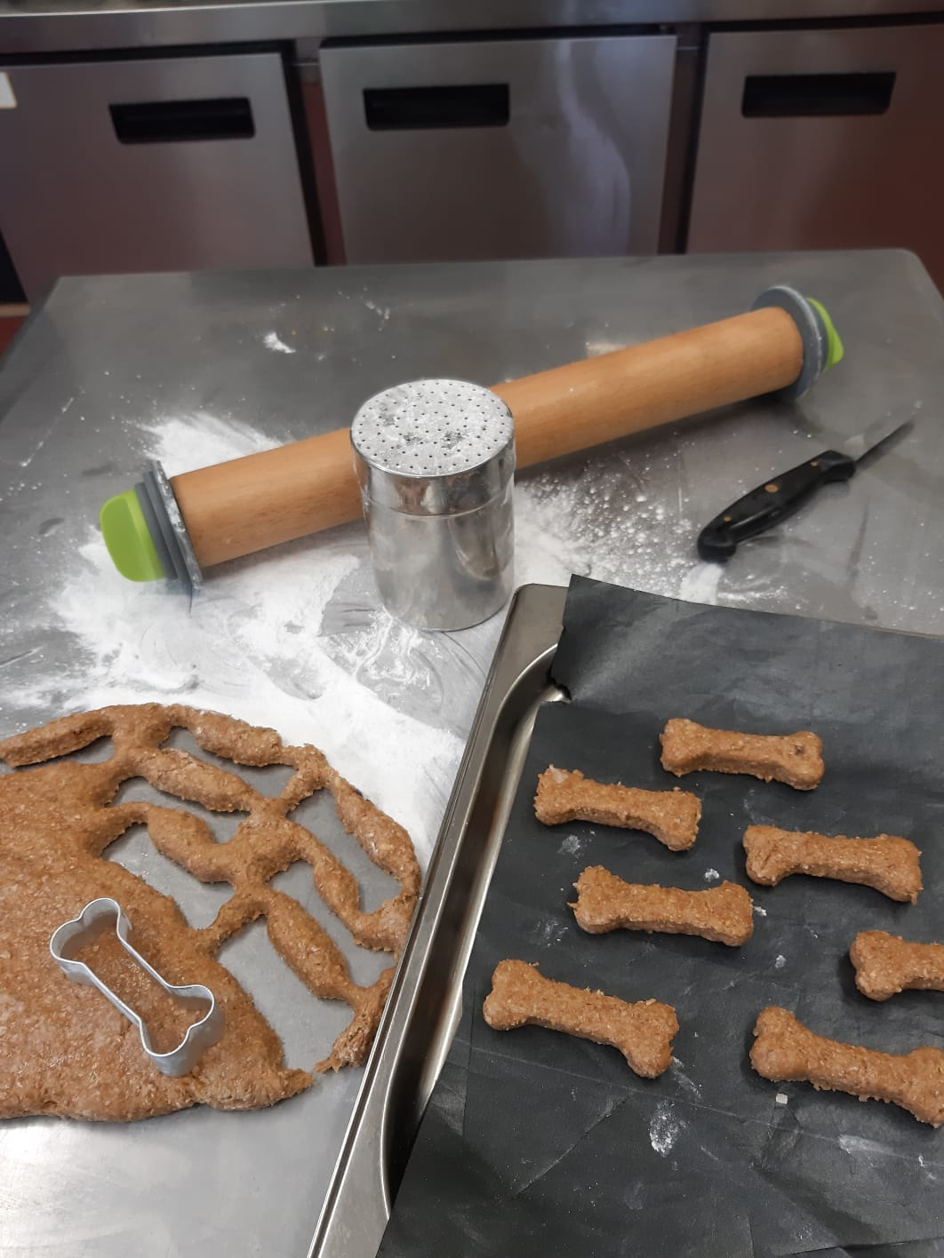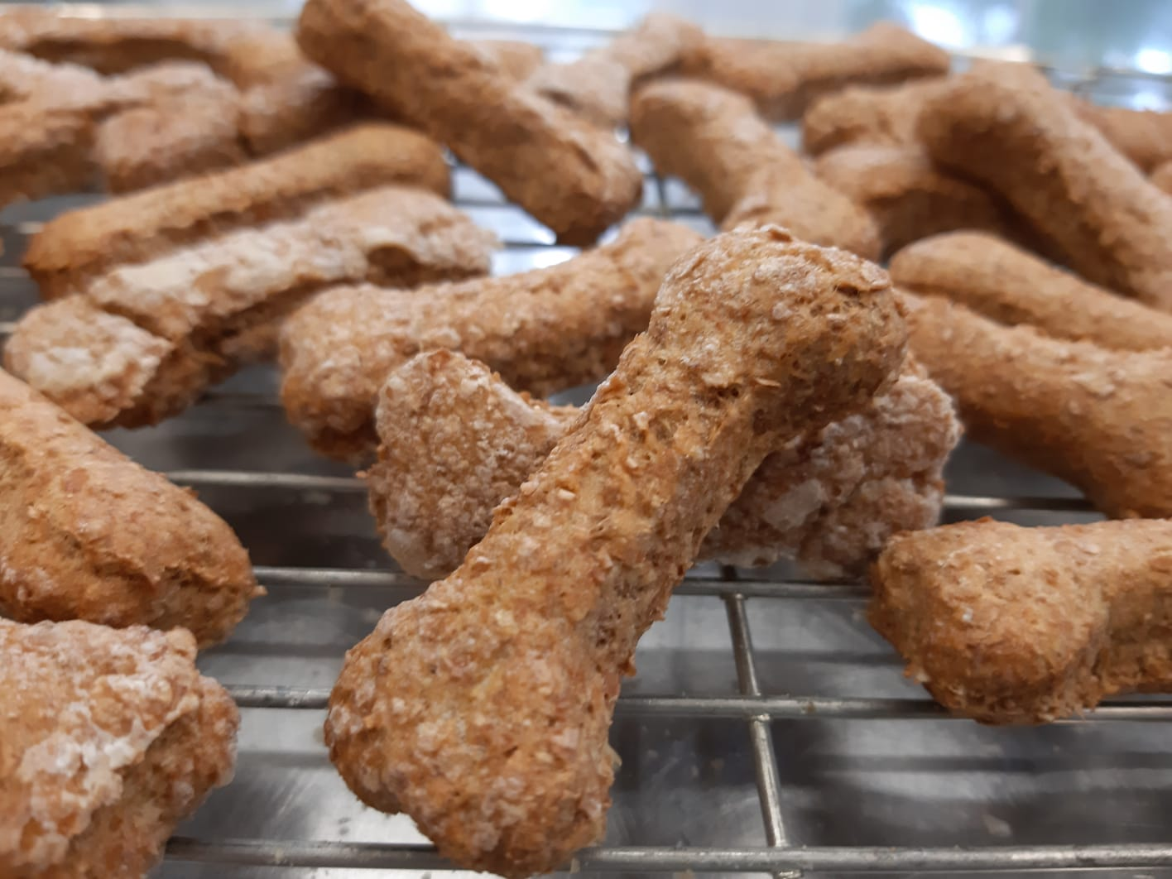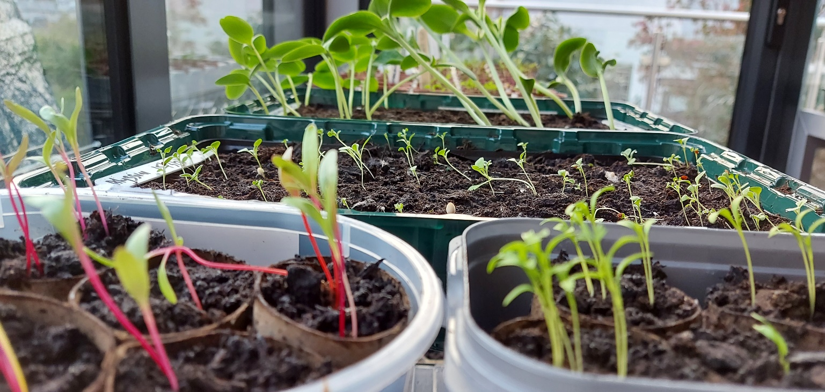

Wearing my Head of Security hat, I am pleased to report that crime remains low in the village. Apart from a sheepish escapee and a minor situation where some chickens invaded our garden, there have been no incidents, so you can be confident that you will be safe whilst visiting the village. The chickens have sent on a remedial training course and we had some very nice free-range eggs, so no further action will be taken.

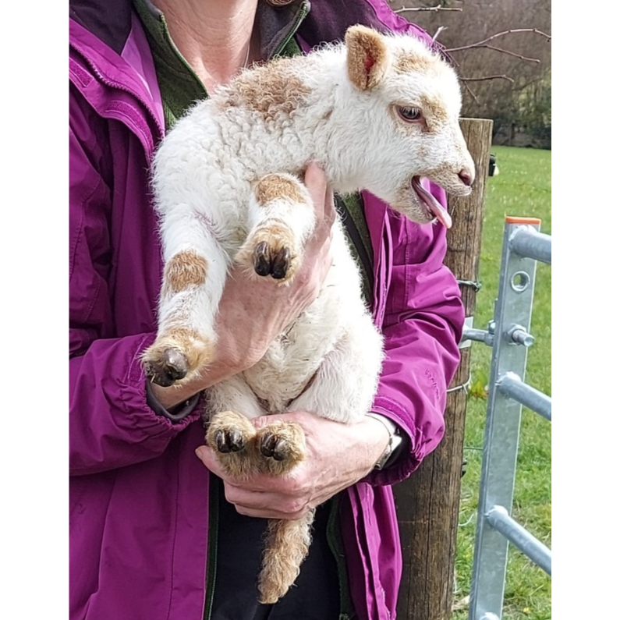
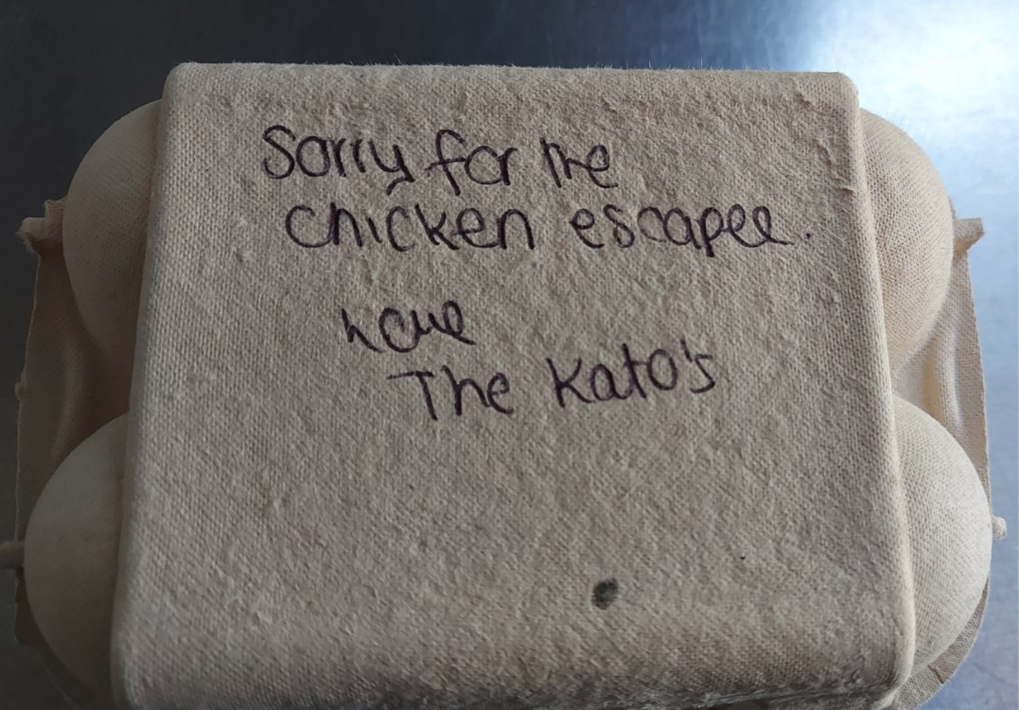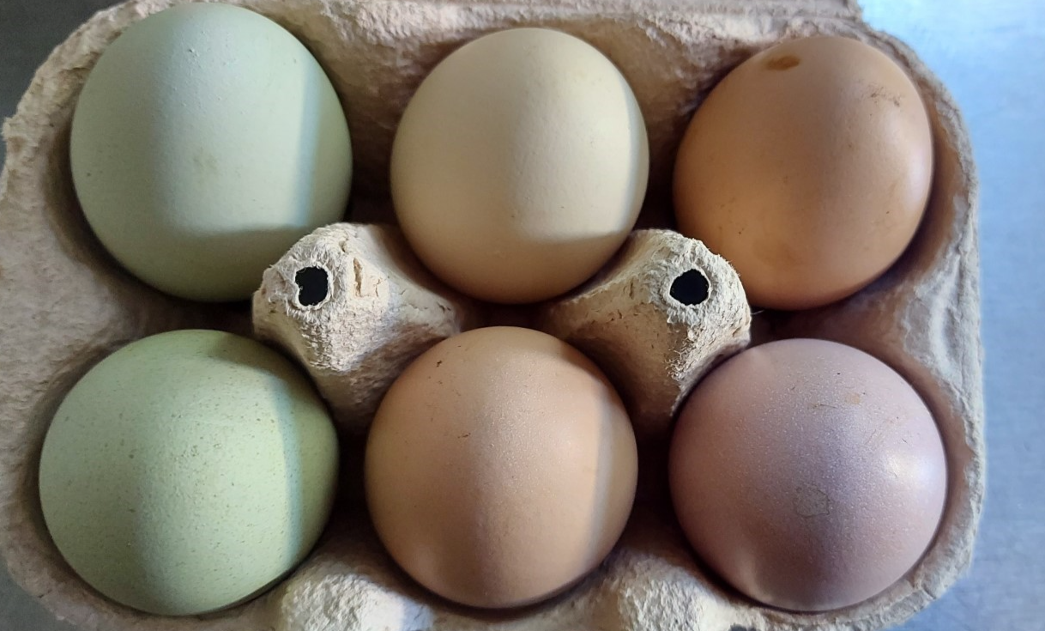

Last year I was relieved of many of my summer duties, I was furloughed as head of security and no longer allowed to meet and greet. Not only did the government ask me to stay at home but for the two short months that my guests were permitted to return, they mainly arrived in ‘bubbles’, which is odd really because most people around here drive Land Rovers. They then had the whole place to themselves, where they were able to bubble to their hearts content. I am told that we were fully booked by groups for the months of August and September, when we were allowed to open. In fact, it worked so well that I have instigated some changes to the kitchen, so that it will work better for groups. The whole exercise was made quite difficult really, as it is where they keep the sausages and I’m not allowed in.
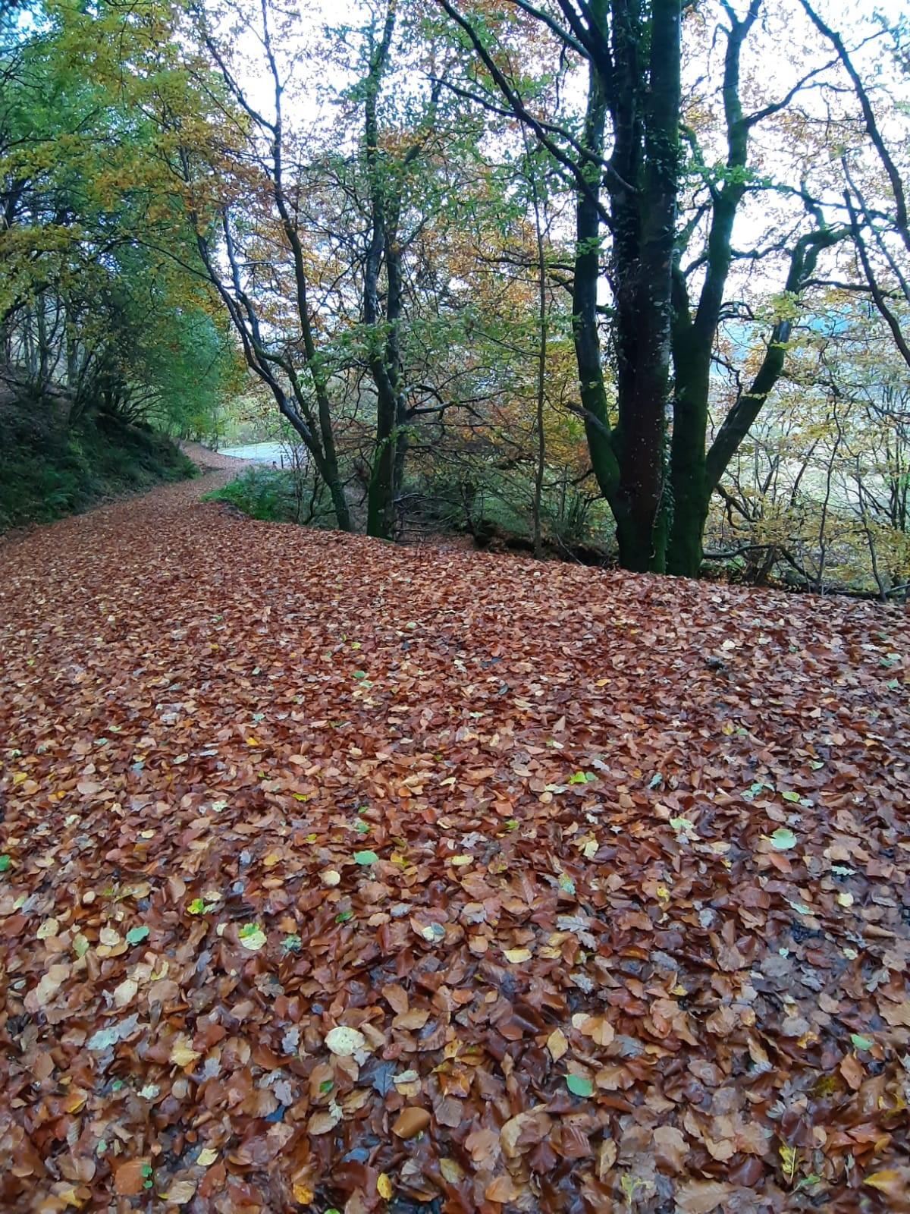
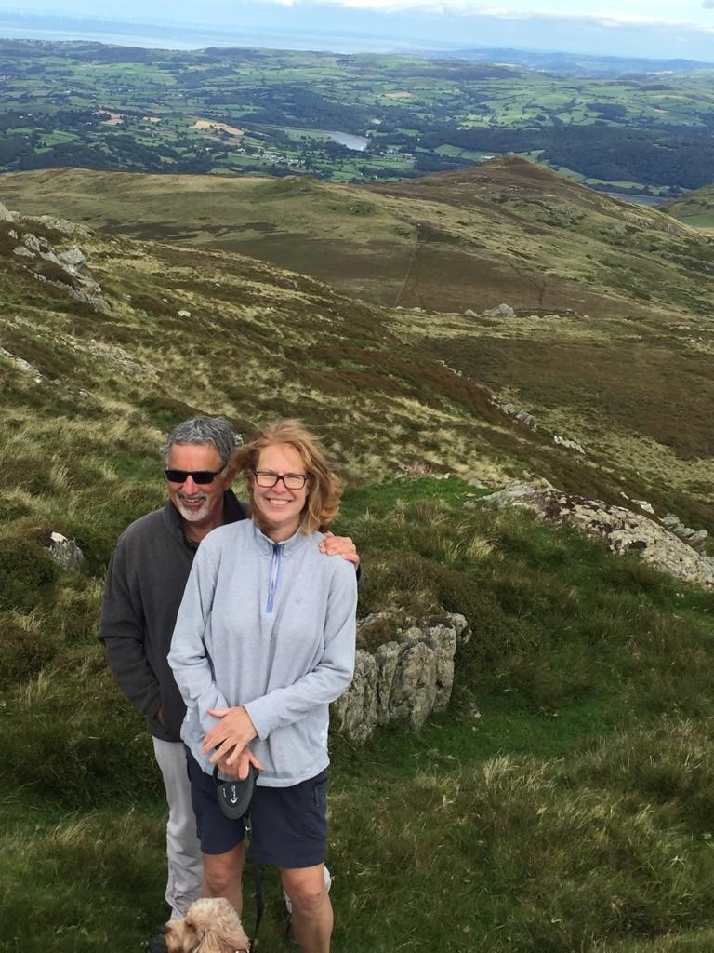
I was hoping that my job as head of hospitality would be re-instated but there are pros and cons to this furlough arrangement: I get far fewer sausages but many more walks. This gave the staff much more time to perform their duties and walk me 5km a day as they should do. Over the winter we went for long mountain walks, which are great but, in my view, you can’t beat the beach for letting your hair down and blowing the cobwebs away.
Unfortunately, we haven’t been to the pub in the village since before Christmas. I say unfortunately because it’s where I’m able to get away from work pressures and relax. The best bit is that there’s always an opportunity for a few crisps or chips - nobody seems to mind if I help keep the floor clean. When we were there last time there was a new marquee with heaters and a carpet to lie on. I don’t know why it is shut other than it might be something to do with Maxine. Hopefully it will be opening again for the summer once everyone is back, I certainly hope so as my vocal chords need re-tuning and I have forgotten most of the Welsh tunes the singers perform on a Friday night.
Can’t wait to have you back!
Lots of love, Ruby xxx

